**Laboratory Assignment 1: Logic Abstraction**

**ECE 0201: Digital Circuits and Systems**

**45 Points**

**Name**

谢君泽 Gabriel 0374 & 张鹤扬 Stefen 0349

**Submission Checklist:**

 Write within boxes, do not move boxes

 Write your full name in the box above

 Save this file as a PDF before uploading, keep the number of pages (**13**) unchanged

 Note “TO BE CONTINUED” in the answer box if you used the extra pages (11-13)

**Part I: Single Input LED/Switch Circuits (10 points)**

**LED and Switch in Series (2.5 points)**

[(A) Insert a picture of your build of the circuit] (0.5 points)

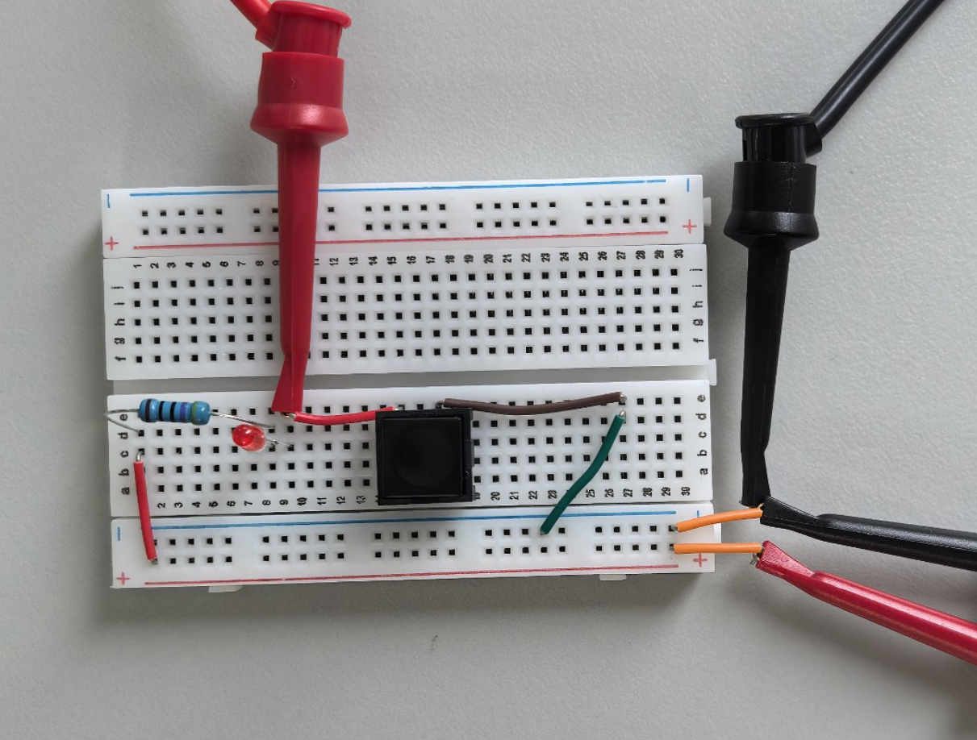

[(B) Fill out the following information] (1 points)

Vx when the switch is closed = 0.337mV

Vx when the switch is opened = 3.536V

LED state (on/off) when the switch is open = OFF

LED state (on/off) when the switch is closed = ON

[(C) Briefly compare your voltage measurements to what you expect] (1 points)

1. When the switch is off, the voltmeter is shorted and shows 0V. Since the wire and switch have resistance, once the switch is open, the circuit becomes open, and the voltmeter should read 5V. But as stated in the instructions, the LED has a typical forward voltage of 1.7V. Therefore, it is reasonable that the voltmeter displays 3.536V, indicating a 1.5V drop across the LED, which is very close to the typical value.

**LED and Switch in Parallel (7.5 points)**

[(A) Insert a picture of your build of the circuit shown in Figure 5] (0.5 points)

图片包含 游戏机, 桌子

AI 生成的内容可能不正确。

[(B) Fill out the following information] (1 points)

Vx when the switch is closed = 0.630mV

Vx when the switch is opened = 1.94845V

LED state (on/off) when the switch is open = ON

LED state (on/off) when the switch is closed = OFF

[(C) Briefly compare your voltage measurements to what you expect.] (1 points)

1. When the switch is open, the LED lights up and operates normally. Vx represents the potential difference across the LED. Since R1 takes part of the voltage, the measured Vx matches expectations.
2. When the switch is closed, the LED is bypassed, and no current flows through it, so Vx should be 0V. Because the wire has resistance, a slight voltage appears, making Vx equal to 0.630 mV, which is reasonable.

[(D) Demonstrate your circuit to an instructor or TA for the first part of the lab checkoff] (5 points)

**Part II: Multiple Input Switch / LED Circuits (20 points)**

**LED and Two Switches in Series (5 points)**

[(A) Insert a picture of your build of the circuit] (0.5 points)

桌子上放了不同类型的零件

AI 生成的内容可能不正确。

[(B) Fill out the following information] (1.5 points)

|  |  |  |  |  |
| --- | --- | --- | --- | --- |
| S1 | S2 | Vx | Vy | LED (on/off) |
| Open | Open | 3.5326V | -0.005mV | OFF |
| Open | Closed | 3.5357V | 0.279mV | OFF |
| Closed | Open | 3.5363V | 3.5457V | OFF |
| Closed | Closed | 0.540mV | 0.660mV | ON |

Assume:

switch close is 1, open is 0;

LED on is 1, off is 0.

The 2 switches are 2 inputs, the LED is an output.

The output is true only if both inputs are true, so we can say it is an AND.

[(C) Select a logic abstraction, draw a truth table, and explain what type of logic gate this circuit represents] (1.5 points)

Logic abstraction: AND

Truth table (1-T,0-F)

|  |  |  |
| --- | --- | --- |
| S1 | S2 | Result |
| 0 | 0 | 0 |
| 0 | 1 | 0 |
| 1 | 0 | 0 |
| 1 | 1 | 1 |

Assume:

switch close is 0, open is 1;

LED on is 0, off is 1.

The 2 switches are 2 inputs, the LED is an output.

If there is a 1 in the 2 inputs, the result is 1. So, it can be an OR.

[(D) Draw a second truth table with a second logic abstraction (no need to retake measurements)] (1.5 points)

Logic abstraction: OR

Truth table

|  |  |  |
| --- | --- | --- |
| S1 | S2 | Result |
| 1 | 1 | 1 |
| 1 | 0 | 1 |
| 0 | 1 | 1 |
| 0 | 0 | 0 |

**LED in Parallel with Two Series Switches (5 points)**

This wire is prepared for voltage measurement.

[(A) Insert a picture of your build of the circuit] (0.5 points)

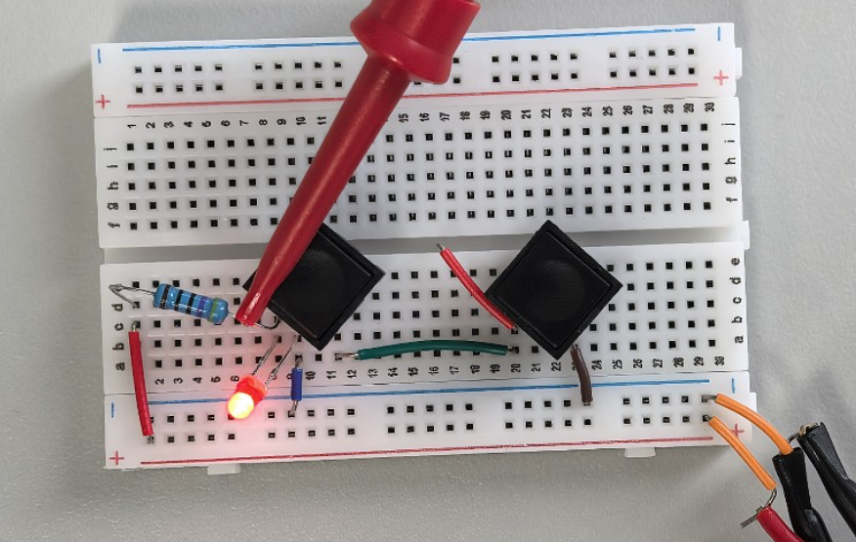

[(B) Fill out the following information] (1.5 points)

|  |  |  |  |  |
| --- | --- | --- | --- | --- |
| S1 | S2 | Vx | Vy | LED (on/off) |
| Open | Open | 1.94881V | 0.435mV | ON |
| Open | Closed | 1.94738V | 0.052mV | ON |
| Closed | Open | 1.94771V | 1.94715V | ON |
| Closed | Closed | 0.922mV | 0.446mV | OFF |

Assume:

switch close is 1, open is 0;

LED on is 0, off is 1.

The 2 switches are 2 inputs, the LED is an output.

If and only if there are double 1, the result is 1, it is an AND.

[(C) Select a logic abstraction, draw a truth table, and explain what type of logic gate this circuit represents] (1.5 points)

Logic abstraction: AND

Truth table

|  |  |  |
| --- | --- | --- |
| S1 | S2 | Result |
| 0 | 0 | 0 |
| 0 | 1 | 0 |
| 1 | 0 | 0 |
| 1 | 1 | 1 |

Assume:

switch close is 0, open is 1;

LED on is 1, off is 0.

The 2 switches are 2 inputs, the LED is an output.

If there is more than one value of 1, the result is 1. It’s an OR.

[(D) Draw a second truth table with a second logic abstraction (no need to retake measurements)] (1.5 points)

Logic abstraction: OR

Truth table

|  |  |  |
| --- | --- | --- |
| S1 | S2 | Result |
| 1 | 1 | 1 |
| 1 | 0 | 1 |
| 0 | 1 | 1 |
| 0 | 0 | 0 |

**LED in Series with Two Parallel Switches (5 points)**

[(A) Insert a picture of your build of the circuit] (0.5 points)

图片包含 游戏机, 桌子, 不同, 厨房

AI 生成的内容可能不正确。

[(B) Fill out the following information] (1.5 points)

|  |  |  |  |  |
| --- | --- | --- | --- | --- |
| S1 | S2 | Vx | Vy | LED (on/off) |
| Open | Open | 3.5358V | 3.5358V | OFF |
| Open | Closed | 0.410mV | 0.409mV | ON |
| Closed | Open | 0.383mV | 0.385mV | ON |
| Closed | Closed | 0.250mV | 0.248mV | ON |

Assume:

switch close is 1, open is 0;

LED off is 0, on is 1.

The 2 switches are 2 inputs, the LED is an output.

If there is more than one value of 1, the result is 1. It’s an OR.

[(C) Select a logic abstraction, draw a truth table, and explain what type of logic gate this circuit represents] (1.5 points)

Logic abstraction: OR

Truth table

|  |  |  |
| --- | --- | --- |
| S1 | S2 | Result |
| 0 | 0 | 0 |
| 0 | 1 | 1 |
| 1 | 0 | 1 |
| 1 | 1 | 1 |

Assume:

switch close is 0, open is 1;

LED on is 0, off is 1.

The 2 switches are 2 inputs, the LED is an output.

If and only if all the switches are 1, the result is 1. It’s the AND.

[(D) Draw a second truth table with a second logic abstraction (no need to retake measurements)] (1.5 points)

Logic abstraction: AND

Truth table

|  |  |  |
| --- | --- | --- |
| S1 | S2 | Result |
| 1 | 1 | 1 |
| 1 | 0 | 0 |
| 0 | 1 | 0 |
| 0 | 0 | 0 |

**LED in Parallel with Two Parallel Switches (5 points)**

[(A) Insert a picture of your build of the circuit] (0.5 points)

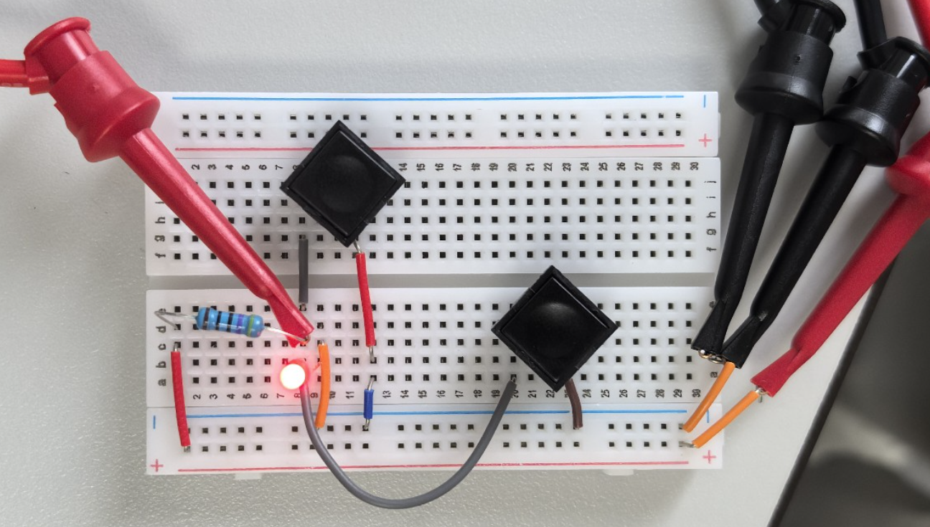

[(B) Fill out the following information] (1.5 points)

|  |  |  |  |
| --- | --- | --- | --- |
| S1 | S2 | Vx | LED (on/off) |
| Open | Open | 1.94939V | ON |
| Open | Closed | 0.671mV | OFF |
| Closed | Open | 0.734mV | OFF |
| Closed | Closed | 0.440mV | OFF |

Assume:

switch close is 0, open is 1;

LED on is 1, off is 0.

The 2 switches are 2 inputs, the LED is an output.

If and only if all the switches are 1, the result is 1. It’s the AND.

[(C) Select a logic abstraction, draw a truth table, and explain what type of logic gate this circuit represents] (1.5 points)

Logic abstraction: AND

Truth table

|  |  |  |
| --- | --- | --- |
| S1 | S2 | Result |
| 1 | 1 | 1 |
| 1 | 0 | 0 |
| 0 | 1 | 0 |
| 0 | 0 | 0 |

Assume:

switch close is 1, open is 0;

LED on is 0, off is 1.

The 2 switches are 2 inputs, the LED is an output.

If there is more than one value of 1, the result is 1. It’s an OR.

[(D) Draw a second truth table with a second logic abstraction (no need to retake measurements)] (1.5 points)

Logic abstraction: OR

Truth table

|  |  |  |
| --- | --- | --- |
| S1 | S2 | Result |
| 0 | 0 | 0 |
| 0 | 1 | 1 |
| 1 | 0 | 1 |
| 1 | 1 | 1 |

**Part III: Logic Design (15 points)**

[(A) Solve the truth table for the provided Boolean function, define a logic abstraction, and draw a circuit schematic] (1.5 points)

Step 1: Solve truth table and define logic abstraction:

|  |  |  |
| --- | --- | --- |
| A | B | f |
| 1 | 1 | 1 |
| 1 | 0 | 0 |
| 0 | 1 | 1 |
| 0 | 0 | 1 |

Step 2: Develop and draw circuit schematic:

图片包含 图表

AI 生成的内容可能不正确。TO BE CONTINUED

[(B) Insert an image of your build of the circuit you designed] (0.5 points)

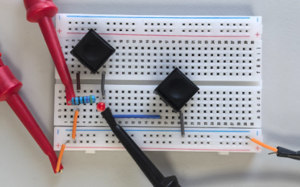

[(C) Organize your measurements into a single table showing switch states, voltage measurements, and LED states. Also, translate the table into a truth table showing logical values] (1.5 points)

|  |  |  |  |
| --- | --- | --- | --- |
| S1 | S2 | Vx | LED (on/off) |
| Open | Open | -28.197mV | OFF |
| Open | Closed | -0.005mV | OFF |
| Closed | Open | 4.9976V | ON |
| Closed | Closed | 0.150V | OFF |

Truth table

|  |  |  |
| --- | --- | --- |
| S1 | S2 | Result |
| 0 | 0 | 1 |
| 0 | 1 | 1 |
| 1 | 0 | 0 |
| 1 | 1 | 1 |

Assume:

switch close is 1, open is 0;

LED on is 0, off is 1.

The 2 switches are 2 inputs, the LED is an output.

[Demonstrate your circuit to the instructor or TA for the second part of the lab check-off.] (11.5 points)

**EXTRA PAGES**

[Leave the page unchanged if you are not going to use. Otherwise, specify the problem number you are working on here. Don’t forget to notify “TO BE CONTINUED” in the original problem box]

PART 3-A

Besides the circuit satisfy the stem (1 LED, 2 switches, Vdd=5V), we also designed another circuit, which satisfies instinct better.

The circuit use 2 LEDs, 2 switches. The closed switch (breakover) is 1, and the lighted LED is 1.

Follows the circuit schematic.

图片包含 示意图

AI 生成的内容可能不正确。

Then the truth table

|  |  |  |  |
| --- | --- | --- | --- |
| A | B | Ā | f |
| 1 | 1 | 0 | 1 |
| 1 | 0 | 0 | 0 |
| 0 | 1 | 1 | 1 |
| 0 | 0 | 1 | 1 |

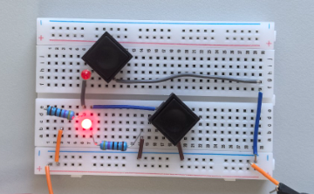

**EXTRA PAGES**

[Leave the page unchanged if you are not going to use. Otherwise, specify the problem number you are working on here. Don’t forget to notify “TO BE CONTINUED” in the original problem box]

**EXTRA PAGES**

[Leave the page unchanged if you are not going to use. Otherwise, specify the problem number you are working on here. Don’t forget to notify “TO BE CONTINUED” in the original problem box]